Accounting for Software Costs
Appendix D - Recommended Tracking Models for Internally- Developed Software Projects
Payroll and payroll-related costs for employees who are working on the second stage of the internally-developed software project is allowable on non-sponsored funds, but not on sponsored funds. Only costs integral to developing the software may be charged to the WIP object codes for sponsored funds. Integral costs include any material or supply that becomes a permanent part of the software development, any internal service center charges, and any external shop fees. Harvard labor costs which are outside of a service center cannot be capitalized and charged to the WIP object codes when using sponsored funds.
If an internally-developed software project meets requirements around splitting out labor costs on non-sponsored funds and has estimated costs above the capitalization thresholds, tubs must track and document time, salary and other costs incurred in each of the development stages. Internal employee costs (salary and fringe) must be tracked using a GAAP-compliant method, suggested models include:
Internally-developed software costs are charged using a software object code and unique Work in Progress (WIP) activity assigned to a project. A placeholder asset using tag number, activity, or other unique identifier must be created in Oracle Fixed Assets to track associated transactions.
Monthly tracking: track individual employee time on a monthly basis using a form completed by the employee or supervisor. The form should detail the hours spent on each capitalizable task for each project. The form then calculates the percentage of time spent on each task for each project and it applies it to either an actual salary by person or a blended salary rate. A finance manager or project manager should review each form to determine the calculation of total salary and fringe to be capitalized each month for each project. See the sample monthly tracking spreadsheet.
Different project stages that tubs may wish to use are:
- Implementation Tasks
- Training Tasks (training costs must be expensed – see appendix)
- Data Tasks
- Process/Organization Design
- Non-Project Tasks
Percentage of time estimate (Labor): At the outset of a project, employee time spent on the project is estimated (using a percentage of time). The cost of time spent on the project is capitalized based on this estimate. The project manager or finance manager should review the project quarterly for significant shifts in employee time spent on the project. In addition, employees or supervisors could be asked to identify significant (generally, greater than 10%) changes in time spent. The sample labor summary tracking spreadsheet can be used for this option as well, but would typically be completed at the beginning of the project or to notify project manager of significant changes.
Note that annual certification is required for projects using the percentage of time estimate. If a tub uses a method to estimate the percentage of time an employee spends on a project, project managers in that tub must certify at least annually that the time estimates are reasonable. Project managers may certify more frequently throughout the year as project milestones are met.
Other methods: Approaches other than the two described above must be approved by FAR at the outset of the project.

Sample Monthly Tracking Spreadsheet
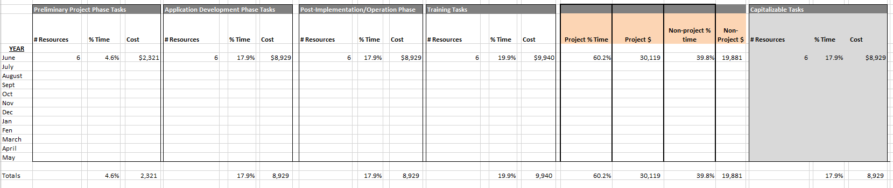

Sample Percentage of Time (Labor) Estimate Spreadsheet
