Appendix D: Detailed Guidance on Disposition, Retirement and Impairment

Basic rules for disposals and impairments:
When an asset has been sold, demolished, is no longer in service or its value has been permanently impaired, any remaining value of the asset, net of accumulated depreciation, less any salvage value, must be written off or written down to its net realizable value. This involves removing both the asset and the accumulated depreciation from the general ledger and the Assets Inventory System and recognizing a gain or loss for the difference. Any outstanding loans on debt-financed assets that are being written off must be settled before impairments can be written off.
Complete the Equipment Disposal Request Form and attach to the asset inside of the Oracle Financial system.
- Types of Disposals:
- Sales of Assets
- Sales of Buildings or Property
All sales and demolitions to the physical plant should be specified in the capital plan narratives (MYCP and/or one-year capital budget). Sales and demolitions will be subject to review by the Provost and review by the Executive Vice President (EVP), with input from the Planning Office and Campus Services.
Acquisitions and dispositions not included in CPATH or in the capital plan will be handled as Exceptions requiring review by the Provost and review by the EVP, with input from the Planning Office and Campus Services.”
- Equipment Sales
Any request to sell capital equipment must be reviewed and approved by the area-level equipment manager before the equipment can be removed from University premises or oversight. The University does not allow the sale of sponsor-funded equipment; exceptions to this policy are rare and are reviewed by the area equipment manager, area sponsored research office, and OSP on a case-by-case basis.
- External Sale – Sales of assets to third parties will result in either a gain or loss on sale. Where proceeds are greater than the net book value of the asset (historical cost less accumulated depreciation), the gain is credited to object code 5772, “Gain on sale, Capital Asset^Miscellaneous Income, External.” Conversely, where proceeds are less than the net book value of the asset, the loss is debited to object code 8722, “Loss on sale of capital asset.” In either case, the local fixed asset manager or school or unit finance office must write off the asset through Oracle Fixed Assets. If the asset is not yet fully depreciated, Financial Accounting and Reporting (FAR) must transfer any remaining plant equity to operating net assets as a below-the-line internal transfer (non-operating activity). See the University’s Internal Transfer Policy for further information. When selling assets, any outstanding loans relating to the assets must be settled; consult the Office of Treasury Management (OTM) in these cases. Communicate all external sales, including relevant asset numbers, retirement report, detail on cash receipt coding from sales proceeds, and the transaction listing for any o/c 8722 write-off, to Financial Accounting and Reporting (FAR), as there may be additional accounting entries necessary.
Sales or Unrelated Business Income Tax may apply. Contact the Tax Reporting Office for additional information.
- Internal Sale – When an asset is sold or transferred between schools or units, no gain or loss on the transaction may be recorded since the asset is still owned by the University, and gains or losses may not be internally generated. The asset is transferred at the net book value at the time of sale. Transfer request must be done through FAR as the assets need to be reassigned between the two schools/units in Oracle Fixed Assets. Any amount exchanged in excess of the net book value is recorded through the 9300 range of object codes as a below-the-line internal transfer (non-operating activity), and would not affect the net book value of the asset. The school or unit transferring assets should contact FAR to ensure that the corresponding plant equity is transferred along with the asset. See the University’s Internal Transfer Policy for further information. For buildings, the root number remains the same; FAR updates the root’s attributes to reflect the building’s new owner and any change to the building’s primary use.
- Demolition
- Partial demolition – In cases where part of a structure is being demolished so that a new addition may be built, the costs related to the partial demolition are capitalized to the new capital project by coding invoices to the CIP object code 1254, “CIP, Demo+Site Prep.” The historical costs associated with the asset that is being partially demolished must be written off in Oracle Fixed Assets, meaning prior CAPS or CPATH projects affiliated with the same space/building must be evaluated for impairment. The write-down of a partially demolished capital asset must be done in Oracle Fixed Assets by the school or unit Financial Office or Fixed Asset Manager. No additional entries are required as Oracle Fixed Assets will record the corresponding loss on disposal and transfer of plant equity.
- Full demolition – When an entire building or piece of equipment is demolished, the asset and accumulated depreciation are written off, and a loss on demolition is recorded to object code 8722, “Loss on Sale/Disposal of Capital Asset” for the difference. The costs associated with the demolition are expensed as incurred. The write-off of a capital asset must be done in Oracle Fixed Assets by the school or unit’s Financial Office or Fixed Asset Manager. No additional entries are required as Oracle Fixed Assets will record the corresponding loss on disposal and transfer of plant equity. When disposing of assets, any outstanding loans relating to the assets must be settled; contact OTM in these cases.
- Departing Staff/Faculty Transfers
Equipment assets that are transferred with a departing faculty or staff member are handled based on how the assets have been accounted for and who has title to the assets. Note that school or other local policy may apply.
- If the assets are recorded in Oracle Fixed Assets at zero value for the purposes of tracking, then local asset managers retire these assets on Oracle Fixed Assets (this would have been done with equipment that was transferred to the University by another institution, by the faculty member). If the University does not have title to these assets, no gain or loss is recorded.
- If the assets belong to the University, then the assets need to be retired, which may result in a loss (if the equipment is not fully depreciated) or a gain (if payment is made upon the transfer of equipment – see also equipment sales above). Depending on the type of transaction (gift or sale to the faculty, staff member) Payroll should be contacted to ensure any benefit to the faculty or staff member is properly recorded. If cash is exchanged for the asset, contact FAR, in accordance with the requirements of asset sales.
- Questions on how to determine fair market value can be directed to FAR.
- Sponsored Assets
Sponsored assets may require prior approval from the sponsoring agency before disposal or removal from service. For any type of disposal, departments must complete the Equipment Disposal Request Form or equivalent documentation and provide it to their school’s equipment management office. Disposal of sponsored equipment is subject to the approval and conditions of the federal sponsoring agency. If the title of the asset belongs to someone other than Harvard, no gain or loss should be recorded on the transaction. These assets should have a zero value in Oracle Fixed Assets. See Appendix A for more information on sponsored assets.
- Writing Off Work in Progress/Construction in Progress (WIP/CIP)
Equipment work in progress and/or construction in progress costs that have been on the general ledger for an extended period of time (i.e., more than one year) where the project has been either abandoned or significantly altered from its original plan must be written off. A loss is recorded to object code 8722, “Loss on sale/disposal of capital asset.
- Assets No Longer in Service
If assets are no longer in service, they must be written down to their estimated remaining value or, in some cases, written off entirely. This write-down or write-off is accounted for in the same manner described in the “Sales of assets” and “Demolition” sections of this document.
- Accounting for Fully Depreciated Assets
Assets that are fully depreciated (i.e., the net book value of the historical cost less accumulated depreciation is zero) and that are no longer in use must be written off. This process is performed at the School or unit level in Oracle Fixed Assets.
- Physical Inventories
Discrepancies noted during a physical inventory are to be recorded in conjunction with the completion of the physical inventory. Any inventory discrepancies noted during the inventory must be written off in Oracle Fixed Assets. The corresponding loss will be recorded to object code 8722, “Loss on sale or disposal of capital asset.” In addition, any assets that are found to be impaired must be written down to their estimated remaining value.
- Disposition
Disposition is the process of removing equipment from inventory that has no further University use. Any piece of capital equipment that no longer functions or for which Harvard has no further use must be physically disposed of and removed from University records. The Oracle Fixed Assets system refers to dispositions as “retirements.” Disposition is required when equipment is:
- No longer in use nor expected to have future use;
- No longer the responsibility of Harvard University (e.g., transferred or sold); or
- No longer part of the inventory of active items
Equipment purchased with federal or other sponsored funds are often subject to sponsor-specific disposition restrictions and cannot be disposed of without prior approval. The Equipment Disposal Request Form is required for disposition of equipment.
If equipment is being retained for parts only, the status in Oracle Fixed Assets must be changed to “scrap.”
Tags must be physically removed from equipment upon disposition (but NOT upon impairment).
Special Note: equipment disposition requires careful coordination with multiple offices and may have hazardous waste, sensitive data restrictions, and other concerns. Contact your area equipment manager or facilities manager for guidance.
- Retirement
Retirement is the process by which capital equipment owned by Harvard or for which Harvard is responsible is permanently removed from the University’s inventory records. Retirements must be processed in the event of physical disposal, loss or theft, external sale or transfer, trade-in, donation, salvage, or return of capital equipment. Any piece of capital equipment which has ceased to function or for which the University has no future use should be physically disposed of and must be updated in Oracle Fixed Assets to reflect accurate valuation and be removed from any inventory records.
It is the responsibility of the faculty member or department to request approval and disposition instructions from the area equipment manager before capital equipment is removed from University premises and oversight. Any transaction involving a sale, trade-in, or cross-school or unit transfers of capital equipment must also be coordinated with the Financial Accounting and Reporting office (FAR).
- Retirement of Computer Equipment
Massachusetts law and Harvard policy require that electronic media containing confidential information be destroyed or thoroughly erased so that such information cannot be read or reconstructed. In addition, Harvard's license does not permit the transfer of operating systems or other software outside the University. Applications that provide for secure disk erasure and meet these requirements are available for Windows computers (e.g. proposed FAS standard CMRR Secure Disk Erase). A secure file erasure function is built into Mac OSX. See Secure Recycle of University Computers and contact your HUIT or your local Computer Resources or IT Department for additional guidance.
- Retirement of Sponsor-Funded or Sponsor-Titled Equipment. See Appendix A and D.
- Impairment
If assets have been permanently impaired, whether by damage, neglect, technological obsolescence, renovating or demolishing a building, or a change in the economic landscape, such that future expected cash flows from the assets are less than their net book value on the balance sheet, the assets must be written down to their estimated remaining value or, in some cases, written off entirely. Account for this write-down or write-off in the same manner as described in the “Sales of assets” and “Demolition” sections of this document. Partially impaired equipment assets remain part of the University’s physical inventory. The Oracle Fixed Assets system refers to impairments as “partial retirements.”
Impairment is defined as the condition that exists when the carrying amount of a long-lived asset exceeds its fair value. Assets should be tested for recoverability whenever events or changes in circumstances indicate that its carrying amount may not be recoverable. The following are examples of such events from ASC 360-10 Property, Plant and Equipment:
- A significant decrease in the market price of a long-lived asset (asset group)
- A significant adverse change in the extent or manner in which a long-lived asset (asset group) is being used or in its physical condition
- A significant adverse change in legal factors or in the business climate that could affect the value of a long-lived asset (asset group), including an adverse action or assessment by a regulator
- An accumulation of costs significantly in excess of the amount originally expected for the acquisition or construction of a long-lived asset (asset group)
- A current-period operating or cash flow loss combined with a history of operating or cash flow losses or a projection or forecast that demonstrates continuing losses associated with the use of a long-lived asset (asset group)
- A current expectation that, more likely than not, a long-lived asset (asset group) will be sold or otherwise disposed of significantly before the end of its previously estimated useful life. The term more likely than not refers to a level of likelihood that is more than 50 percent.
Common reasons for impairment include, but are not limited to: missing equipment noted during a physical inventory; damaged or obsolete equipment disposed of; and building renovations of space that impair prior construction projects.
- Timing of Recording
Account for disposals due to sale or demolition and transfers of assets in the month of the disposal or transfer, and no later than quarter end.
- School/Unit Review
Buildings must be reviewed for impairment on a quarterly basis, or at any time that a capital project commences but no later than approval of a Construction Authorization for potential impairment impact plus a full review at year end, in accordance with the Internal Controls Matrix.
Equipment assets must be reviewed for impairment/obsolescence during the course of the bi-annual physical inventory.
Child assets must be reviewed for impairment/retirement upon the impairment/retirement of a Parent Asset. However, OFA will not notify the user that there are associated child assets at the time of the transaction on the Parent. The Asset Workbench must be reviewed to identify any related assets.

Examples of Proper Coding for Disposals and Impairments

Example 1
On January 15, 20X1, HRES (school/unit 580) sold a building for $1,000,000 to an external party. The building had an original cost of $700,000 and accumulated depreciation of $210,000 as of January 15, 20X1. This building was debt-financed with a loan for $450,000 which was outstanding at the time of disposal.
The University begins depreciation in the month the asset was purchased or placed into service, with a full month of depreciation expense recorded at the month-end close. When an asset is disposed, no depreciation expense is recorded in the month of disposal. In addition, since this asset predated the conversion to Oracle Fixed Assets, a full year of depreciation was taken in the year the building was acquired.
The sale will result in the following transactions in the GL, across the University:
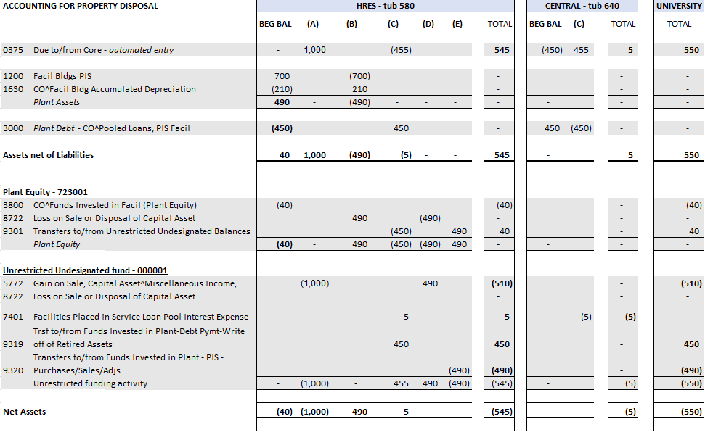
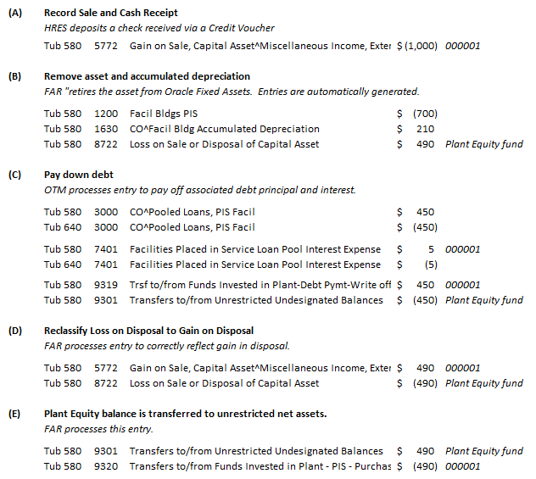

Example 2
On October 12, 20X1, HRES (school/unit 580) transferred land and a building to UOS (school/unit 180). The land has a book value of $850,000. The building has a book value of $500,000, and the accumulated depreciation as of September 30, 20X1 was $25,000. As negotiated by the two school/units, UOS agreed to pay HRES an amount of $100,000. This building was not debt-financed, and there are no outstanding loans at the time of disposal.
The related plant equity balance in fund 724001, Funds Invested in Plant PIS as of September 30, 20X1, is 1,325,000 ($850,000+$500,000 - $25,000). Depreciation will be recorded on school/unit 180’s books as of October 12, 20X1.
The journal entries required to record this internal transfer/sale are as follows:
To transfer the assets and accumulated depreciation from HRES to UOS. These will be system generated entries as the change of ownership of the asset will be changed in Oracle Fixed Assets.
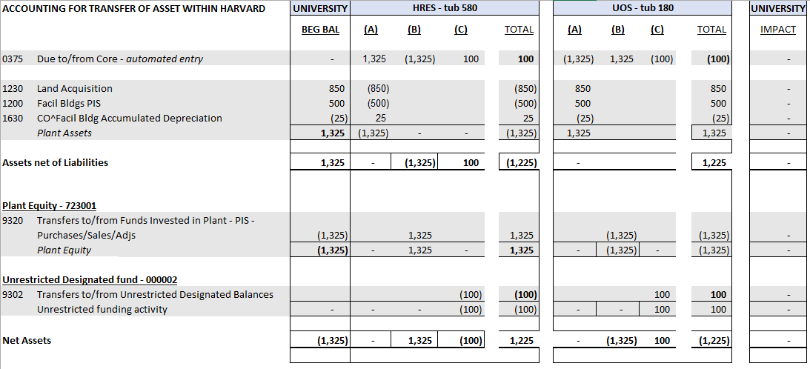
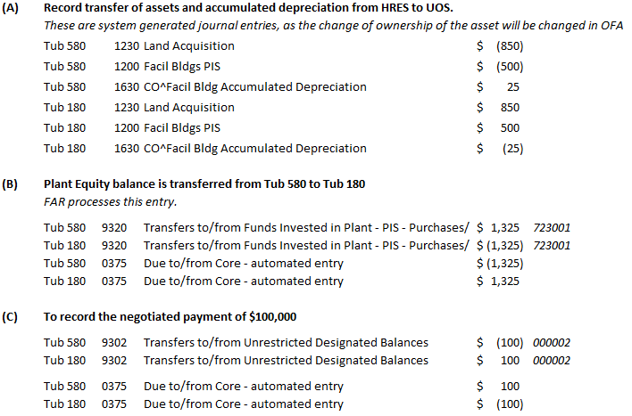
Example 3
On February 12, 20X2, FAS (school/unit 370) disposed of a piece of scientific equipment. The equipment had been purchased in January 20X1 for $40,000. The equipment was disposed of as it was no longer functioning. This piece of equipment was not debt-financed.
All equipment data is housed in Oracle Fixed Assets, as such, FAS’s Fixed Asset Manager will need to retire the equipment in Oracle Fixed Assets. Oracle Fixed Assets will automatically calculate the net book value and the corresponding loss on disposal. This asset was placed in service in January 20X1, using an 8 year useful life with depreciation starting in the month of purchase. Depreciation is not calculated in the month of disposal. The net book value of this asset is $40,000 less 13 months of depreciation, $5,417, for a total of $34,583.
The journal entries generated by Oracle Fixed Assets after FAS’s Fixed Asset Manager retires the asset in the system are automatically posted.
